Luca Chierotti
ECEN 524
2/19/2025
Dr. Kyrarini

ECEN 524 Project 2 Report

Part B1:

For this first part of the project we are tasked with identifying a pretrained model or developing our own method that can detect the dice in the videos. As discussed in class, using simple digital image processing does not work very well. The glare and positioning of the lighting causes significant color variations that makes color masking very difficult and inconsistent. Due to this, my next approach was to use the YOLOe model. This is designed for open-vocabulary detection and segmentation, meaning it can find objects it wasn't specifically trained on by using text or image prompts. The problem with this model is that, again, due to the lighting and general poor quality of the video recordings, using this model was very inconsistent. For example, in one frame the red dice might be perfectly visible and recognized by the model while in the next frame obscured by a hand and unrecognizable by the model. This was mostly due to the low confidence interval of the results the model returned. The YOLOe model even when prompted with “red dice” only gave an average confidence interval of around 10-20% on the red dice in a given frame. This resulted in some frames even dropping below the minimum confidence interval of 5% and not detecting any dice. Due to this inconsistency and poor model performance I decided to move on from using YOLOe. Similarly, due to poor detection performance of the finger joints when a user’s hand was in profile, MediaPose’s was not used for action recognition (i.e. grasping).

My solution to this was to use Meta’s SAM 3 model. This is a unified foundation model for promptable segmentation in images and videos. This means it can detect, segment, and track objects using text prompts. Specifically, if I give the model a frame and prompt it with “dice” it will segment all the dice in the video. Using the following link I was able to download the model:
SAM3 Repository: https://github.com/facebookresearch/sam3
Leaked Weights: https://huggingface.co/1038lab/sam3/tree/main

Unfortunately, the model is free to clone off of github but the trained weights are only available to download off of hugging face via approval from the Meta Research team. Luckily, Reddit is a beautiful resource to circumvent this as I was able to find the leaked weights shared by a reddit user complaining about Meta’s unwillingness to share research. This allowed me to fully implement the model.

To implement the model at its most basic level requires a prompt and a model instantiations:
TEXT_PROMPT = "red dice"

device = "cuda" if torch.cuda.is_available() else "cpu"
print("Using device:", device)

# -----------------------------
# LOAD MODEL
# -----------------------------
model = build_sam3_image_model(
bpe_path=BPE_PATH,
device=device,
eval_mode=True,
checkpoint_path=CKPT,
load_from_HF=False,
)

processor = Sam3Processor(model, device=device)

# -----------------------------
# LOAD IMAGE
# -----------------------------
image = Image.open(IMG_PATH).convert("RGB")
state = processor.set_image(image)

# -----------------------------
# RUN TEXT PROMPT SEGMENTATION
# -----------------------------
out = processor.set_text_prompt(state=state, prompt=TEXT_PROMPT)
masks, boxes, scores = out["masks"], out["boxes"], out["scores"]

The returned masks are what are then overlaid onto the following images to show the results of the model. For reference a random color is assigned to the mask when overlaid onto its corresponding object to highlight the mask. Furthermore, in the testing phase for B1, various prompts were used: “hand”, “blue dice”, “dice”. This was done to understand the accuracy of the model and specificity needed for the prompts. It is important to note that Sam3 only allows for one text prompt per inference. This meant that the combined prompt “green dice, human hand” resulted in either the green dice or human hand being detected. Therefore, all prompts are singular. Only one object is detected per prompt. To prompt for multiple objects, the same model must be prompted multiple times on the same frame.

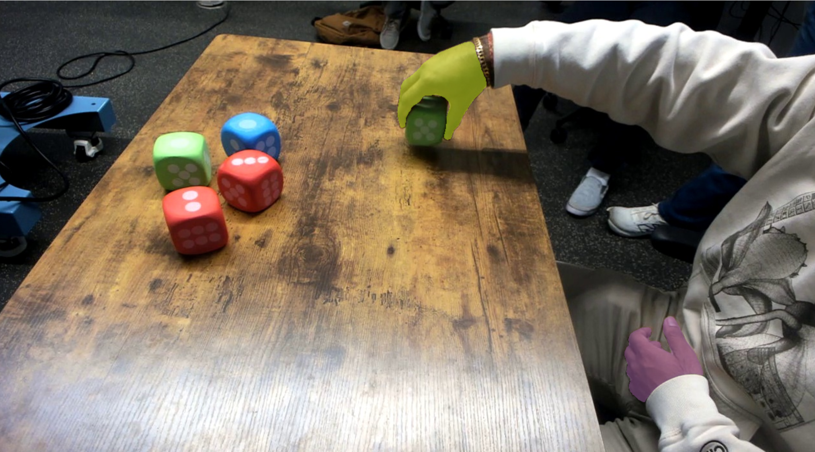
Figure 1: SAM3 Prompted with “hand”

The results of Figure 1 also show how the confidence intervals are much higher than that of YOLOe. Specifically, for Figure 1’s prompt of “hand” these where:
Detected 2 masks
Top confidence: 0.9062322378158569
Mask 0 confidence: 0.9062322378158569
Mask 1 confidence: 0.8670874834060669

We can see that as stated the confidence intervals are now in the 80th and 90th percentile as opposed to the results with YOLOe. Additionally, now the segmentation is pixelwise as opposed to generating bounding boxes with YOLOe. This results in more accurate and precise localization. Overall, this proved the effectiveness of SAM3. However, to better understand the limitations of SAM3 I began by prompting with “dice

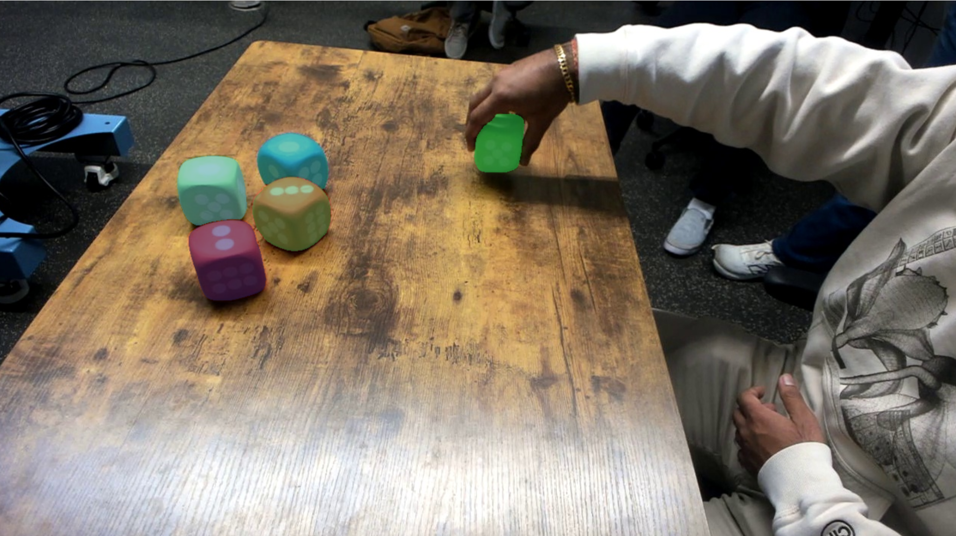
Figure 2: SAM3 Prompted with “dice”

Detected 5 masks
Top confidence: 0.9336540102958679
Mask 0 confidence: 0.9336540102958679
Mask 1 confidence: 0.9372653365135193
Mask 2 confidence: 0.9407848119735718
Mask 3 confidence: 0.9400201439857483
Mask 4 confidence: 0.9186952114105225

And with “red dice”

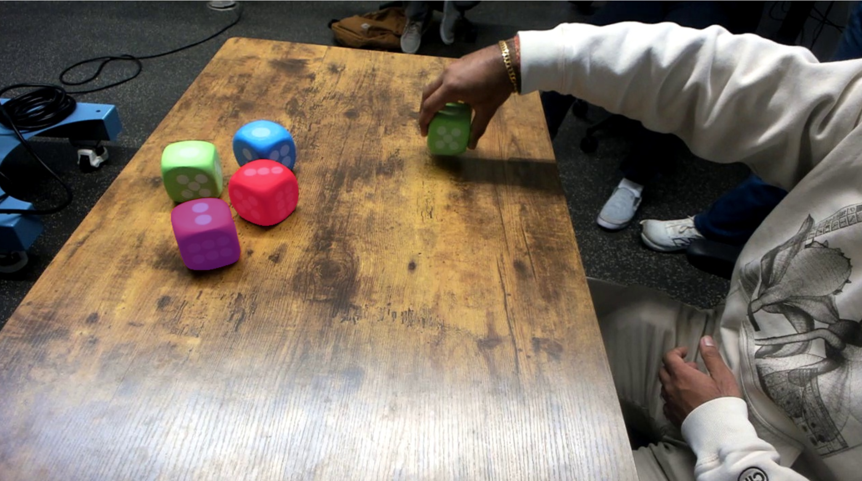
Figure 3: SAM3 Prompted with “ red dice”

Detected 2 masks
Top confidence: 0.9181588292121887
Mask 0 confidence: 0.9181588292121887
Mask 1 confidence: 0.9175729155540466

From the testing frames, we can see how SAM3 correctly identifies all the dice with the prompt “dice” and then the bottom two red dice when prompted with “red dice”. It is important to note that the overlaid masks are of random colors which can make understanding Figure 3 somewhat difficult. However, it does correctly identify the red dice. In fact, tests were run on all individual color prompts. As expected, the results were completely accurate without any incorrect masks. Again, the high confidence interval for the prompts “dice” and “red dice” meant that SAM3 is an effective method for identifying the objects and object color in the videos.

Part B2 and C1:

This section of the project required us to identify a method that can recognize the actions performed in the videos. As previously mentioned due to the user hands consistently being in profile, hand joint prediction models such as media pose were too unreliable to be implemented in the final project. Additionally, the full “grasping”, “holding”, and “placing” sequence of actions was not implemented as described in the project description. Instead, Sam3 was used to detect the order of "picking” and “placing” states for each dice. Specifically, these states were recorded the following format:
PICK <color> from (x, y)
PLACE <color> to (x, y)

where the (x,y) coordinates are the pixel coordinates of a specific die’s centroid.

- Object segmentation

As proven, Sam3 is able to accurately decipher not only what color dice is present but also the user’s hand. Despite this, I do not prompt the model with “green dice” for example. Instead the model is prompted only twice per frame: first with “a die” and second with “a human hand”. As Sam3 can only accurately handle one segmentation task at a time, prompting Sam3 with “green dice”, “red dice”, “blue dice”, and “human hand” requires 4 model inferences per frame. This significantly slows down the compute time, especially since I am running this on my local 5070 laptop gpu. To increase the speed of my code, the model is prompted with “a die” and then “a human hand”. From this Sam3 returns:
1. The segmentation masks of the objects
2. The bounding boxes around each mask
3. The confidence scores

Because there is the risk, be it low, that Sam3 could return multiple overlapping candidate “dice”, my code filters out any low confidence detections just to be safe. This results in a list of dice detections (each with a mask, bounding box, and confidence score). The hand mask is similarly generated.

- Measuring Hand Contact with a Dice

In previous iterations of my code I tried implementing a system which slightly dilated the hand mask and checked if there was a dice whose mask overlapped. This system proved highly inaccurate. In this version euclidean distance (straight line distance) is used instead. What is meant by this is that for each die mask produced in the previous step 1, the distance from each hand pixel to die pixel is calculated. This is done using OpenCV’s distance transform on the inverted hand mask.

def distance_transform_to_hand(hand_mask_bool: np.ndarray) -> np.ndarray:
hand_u8 = hand_mask_bool.astype(np.uint8)
inv = 1 - hand_u8
return cv2.distanceTransform(inv, cv2.DIST_L2, 3)

Then, using this data, I calculate the minimum distance value over all pixels belonging to a given die. If this distance is close to 0, then this means the die’s pixels touch the hand mask and there is strong evidence of being grasped/held. If the distance is large this means the die is separated from the hand and there is a low probability of contact.

However, one thing I noticed is that between frames the masks could have a small amount of pixel noise (jitter) which is caused by the masks slightly shifting between prompt results and thus this minimum distance method to be inaccurate. To solve this bug, I introduced a “contact score”. This reduces the sensitivity of the minimum distance measurement by converting it into a range from 0 to 1:
contact_score = exp(-dmin / sigma)

This produces values near 1.0 when the die is extremely close and values approaching 0.0 as the die moves away from the hand. As the hand mask is often the most reliable cue about “picking” and “placing”, this contact score is the primary signal used by the action logic.

- HSV Color Classification

The next task is to classify the color of the dice mask found by Sam3. To do this digital image processing techniques are used as these are computationally much cheaper than model prompting. Here, the pixels in each mask’s bounding box are converted to HSV. For reference the pixel hue refers to the actual color. The “H” value for each mask’s pixel is compared to the “H” value range for red, green, and blue. If the average number of pixels referring to a color breaches the minimum color confidence interval (35% found through trial and error) then that dice is recognized as that color. Through testing this method is accurate and has not provided any inaccurate readings so far.

pix = frame_bgr[ys, xs]
hsv = cv2.cvtColor(pix.reshape(-1, 1, 3), cv2.COLOR_BGR2HSV).reshape(-1, 3)
h = hsv[:, 0].astype(np.float32)
s = hsv[:, 1].astype(np.float32)
v = hsv[:, 2].astype(np.float32)

if float(np.median(s)) < MIN_COLOR_S_MED or float(np.median(v)) < MIN_COLOR_V_MED:
return None

red = float(np.mean((h < 10) | (h > 170)))
green = float(np.mean((h > 35) & (h < 85)))
blue = float(np.mean((h > 90) & (h < 140)))

scores = {"red": red, "green": green, "blue": blue}
color = max(scores, key=scores.get)
if scores[color] < MIN_COLOR_CONF:
return None
return color

- Classifying Each Dice

After each dice is color classified and given a contact score, they are each “packaged” into a DieDet object containing everything needed for the tracking and action logic needed later on.

@dataclass
class DieDet:
color: str
box: np.ndarray
mask: np.ndarray
score: float
cx: float
cy: float
dmin: float
contact_score: float

Here the color refers to the dice color while the dmin and contact score are related to hand contact. The mask, score, cx, and cy are all outputs from the Sam3 model.

- Global Tracking State

The nature of this project means that only one dice can be picked and placed at a time. Hence, I used this fact to my advantage. Specifically, I implemented a class which gets assigned only to the “grasped” dice during picking and placing.

@dataclass
class GlobalState:
holding: bool = False
hold_color: Optional[str] = None

strong_contact_streak: int = 0
release_streak: int = 0
stable_streak: int = 0
stable_fallback_streak: int = 0

prev_hold_xy: Optional[Tuple[float, float]] = None
prev_hold_mask: Optional[np.ndarray] = None
v_ema: float = 0.0

pick_from: Optional[Tuple[float, float]] = None
pick_time: float = -1e9

stable_obs_streak: Dict[str, int] = field(default_factory=dict)

in_hand_recent: int = 0
last_event_time: float = -1e9

These boolean and integer values are updated

Pick logic

In my code, I defined a “pick” as the dice with
- Strong hand-die contact for N consecutive frames
- The same velocity as the hand

To establish “strong hand-die contact”, I select the dice with the highest contact_score calculated previously. This is the one which is most physically touching the hand. However, as one can expect, a single frame is not enough to establish contact. The user’s hand could just brush by a dice on the way to pick up another. Detecting this false positive needs to be avoided. Hence, to solve this the same dice needs to maintain having the highest contact score for 2 consecutive frames. It is important to note that in my code I am not prompting Sam3 at 60fps. This is computationally too expensive. To resolve this I tried skipping every 4 or even 6 frames between image segmentations. However, this was too inaccurate, leading me to choose to prompt every 2 sampled frames. This results in an effective 30 fps sampling rate or in reality maintaining a highest contact score for 4 actual frames. Again, this value of maintaining 2 consecutive sampled frames was done through trial and error.

However, just having this rule is not enough to establish “picking”. The hand and dice also need to be moving in the same direction with the same velocity. To calculate the velocities, the centroids (cx, cy) are used. Here, I pass the previous and current frame centroids. The change in time, dt, relates to the sampling every 2 frames. Specifically, dt_sec = 2 / 60 fps = 1/30 sec.

def update_velocity(gs: GlobalState, cur_xy: Tuple[float, float], dt_sec: float) -> float:
if gs.prev_hold_xy is None:
gs.prev_hold_xy = cur_xy
gs.v_ema = 0.0
return gs.v_ema
vx = (cur_xy[0] - gs.prev_hold_xy[0]) / max(1e-6, dt_sec)
vy = (cur_xy[1] - gs.prev_hold_xy[1]) / max(1e-6, dt_sec)
v = float(math.hypot(vx, vy))
gs.v_ema = VEL_EMA_ALPHA * gs.v_ema + (1.0 - VEL_EMA_ALPHA) * v
gs.prev_hold_xy = cur_xy
return gs.v_ema

After this the die’s and hand’s speed and displacement are actually compared. If the velocity of the hand and dice are similar and the displacement of the dice is more than just a normal amount of noise (this constant is set to 35 pixels), then we can finally say that this dice is “picked”. The corresponding time, dice color, and centroid location is then logged.

6) Place logic

Since in the previous section, I pre-defined which color dice is being picked up, this naturally means that only that dice can be considered as “placed”. Regardless of this, the demo videos proved difficult in two ways: the user’s hand and other placed dice may occlude the dice during placing and the Sam3 segmentation can still show weak contact even though the dice is no longer grasped (especially if the hand hovers).

To help with these problems multiple methods were implemented. The first being that when holding a dice, only the dice of the “held” color is looked at. Specifically, I compare the previous frame with the current frame. I attempt to match the same color die mask between frames using intersection over union (IoU). For example, if there are two red dice visible, centroid distance alone can snap to the wrong one, especially if they are occluding each other in the “placing” area. IoU overlap has proved to be a stronger way to ensure that the same dice is being remembered between model inferences. The next method is to define when an actual “release” happens. This is defined as “not touching” in two ways: a low contact score and the dice centroid is physically distant from the hand mask.

released_now = (held_det.contact_score < WEAK_CONTACT_SCORE) or (held_det.dmin > RELEASE_DMIN_PX)

For reference a weak contact score was chosen as 0.2 and the minimum pixel distance between the hand and die as 12 pixels.

Unfortunately this method was not enough to ensure that a dice was actually placed. The user’s hand for example might momentarily release the dice and hover over the dice. This could still cause the code to think that the dice is still being held. To solve this a fallback system was created.

fallback_ok_time = (t_sec - gs.pick_time) >= PLACE_FALLBACK_MIN_HOLD_S
fallback_ok_contact = (held_det.contact_score <= PLACE_FALLBACK_MAX_CONTACT)

fallback_ok_stable = (v < STABLE_SPEED_THRESH)

if fallback_ok_time and fallback_ok_contact and fallback_ok_stable:
gs.stable_fallback_streak += 1
else:
gs.stable_fallback_streak = 0

This fallback system works by calculating if enough time has passed since the pick (1 second). This is so there are no hallucinations of an instant pick and place. It also checks again if the contact between the hand and die is not strong. Finally, the dice velocity is checked to see if it is no longer moving. If it is below a threshold of 60 pixels/sec, then it is considered placed. Again these checks only occur after a singular dice is considered picked.

Furthermore, another fallback was generated during testing. Since the setup of our project obviously means that no two dice can be picked in the same spot, “place events” which come from the same starting spot can be omitted. This prevents any weird hallucinations and duplicate states in the output. This is just another safety check. Specifically, if the centroid of the starting position of a dice is very similar to another previous “held” dice then that action is discarded.

7) Results

This code was initially tested and run on Demo 2 and provided accurate results. However, when this was extended to all videos, my algorithm did not generalize well:

Table 1: Sequence of Action Report for all Demos
Demo 1  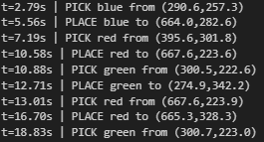 | Demo 2  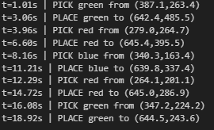
Demo 3  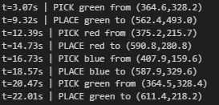 | Demo 4  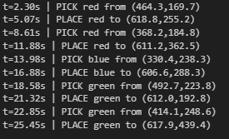
Demo 5  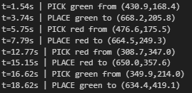 | Demo 6  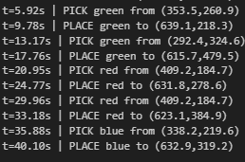
Demo 7  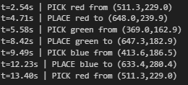 | Demo 8  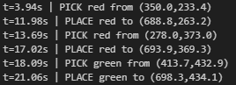
Demo 9  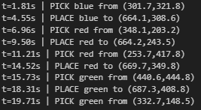 | Demo 10  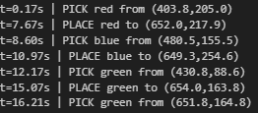

From the results of my algorithm, we can see only 3 demos where successful in mapping the full action sequence. These Demos (2, 4, and 6) contain the correct number of pick and place pairs and in the correct order for their respective demo video. Not only do these demos visually match the order of their videos, but the time index and pixel centroid coordinates also match. We can see how in these demos, the final x-coordinate for all the dice lie around x = 650. This is expected as the dice are all placed in one vertical straight row in the videos. Here are some screen shots of the successful Demo 2:

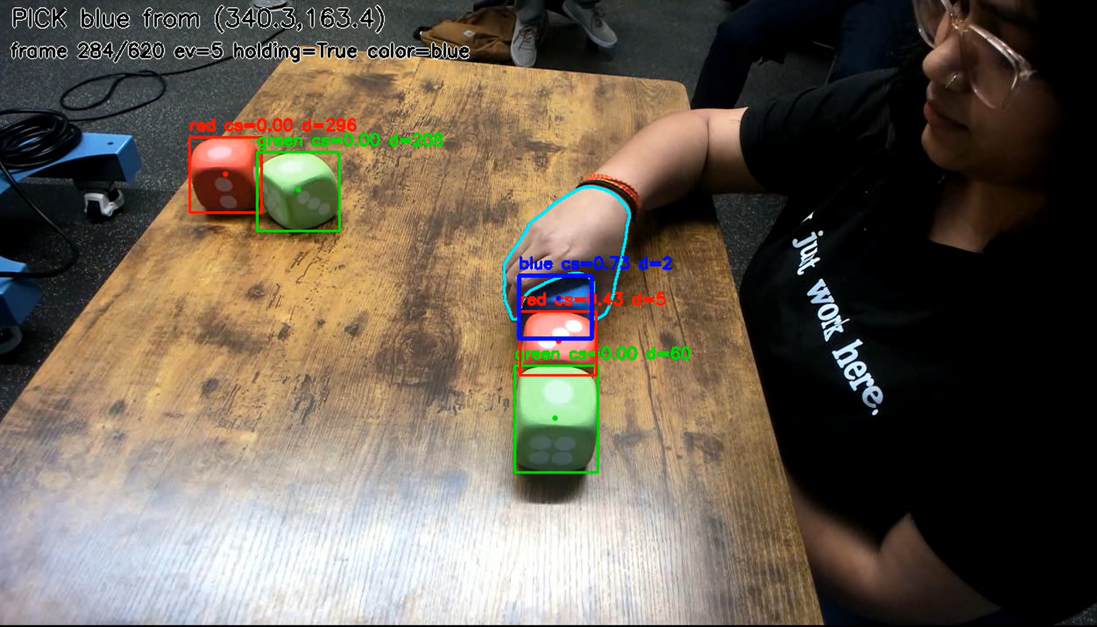
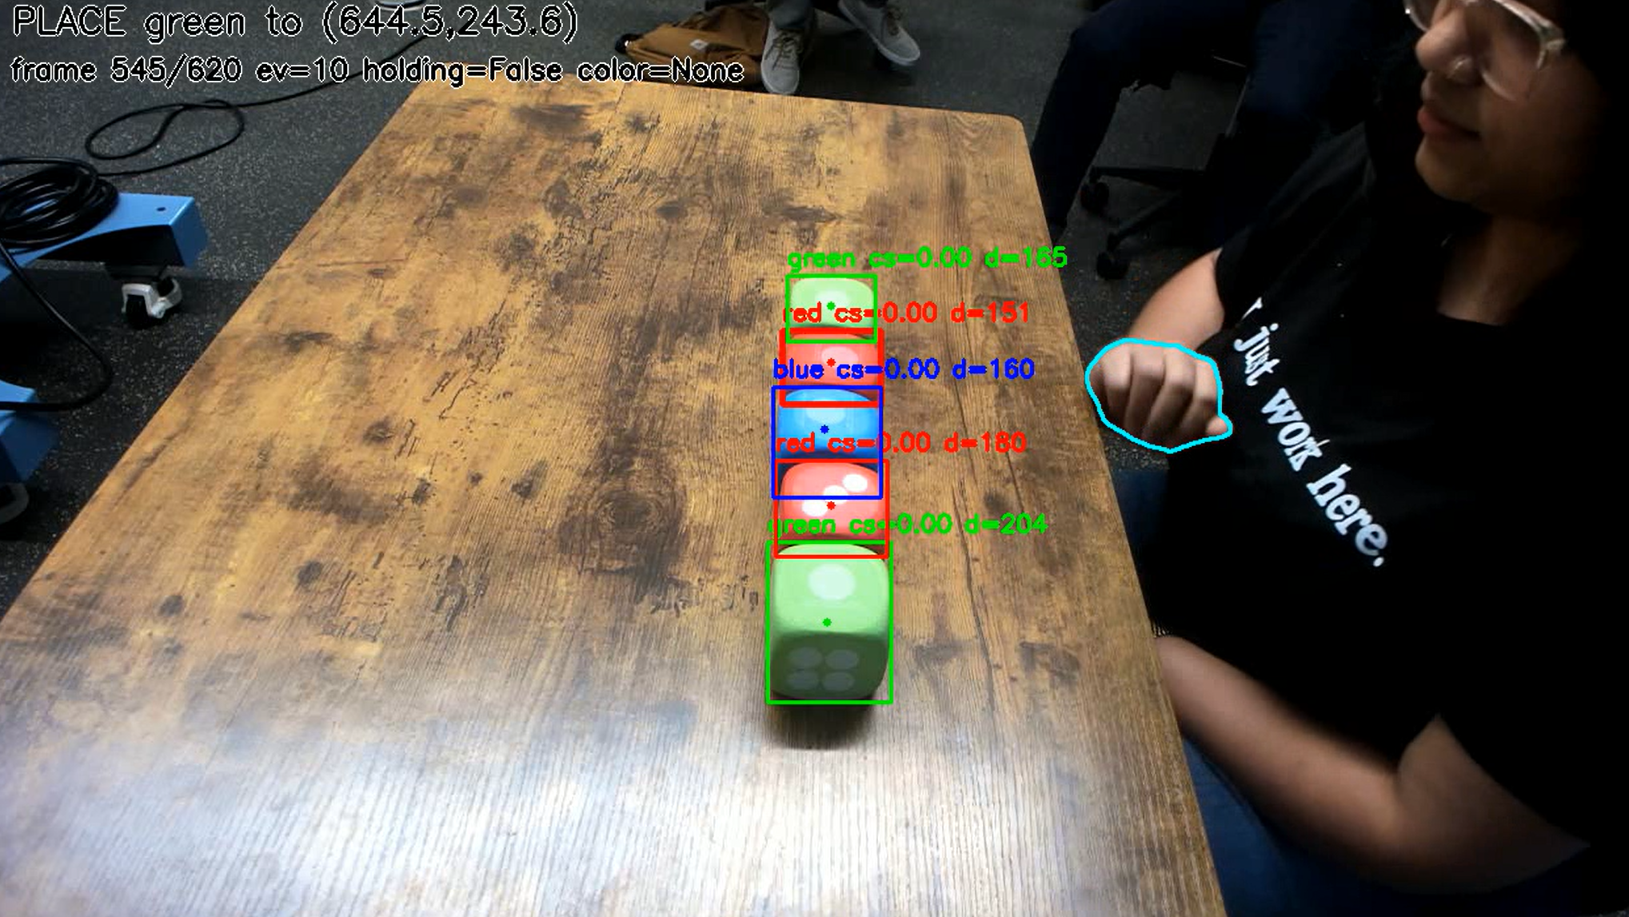
Figure 4: Sample Frames from the Annotated Results of Demo 2

Unfortunately, the Demos 1 and 9 contain all the correct pick and place actions except for their final place. Demo 1 and 9 are both missing the “place” action of the green dice. Regardless of this the previous action pairs in these demos are all correct.

Similarly Demo 3 and 5 are missing their final pick and place pair (pick and place) while Demos 7, 8, and 9 are missing multiple pairs. Thus, this method is not generalizable to all demos. However, the one positive is that it can still detect at least 3 of the first 5 “pick-place” action pairs in all videos. The reason for this has to be related to the overall structure of my code. I use a lot of fixed threshold constants in my picking and placing logic (ex: minimum pixels or minimum speeds) which were tuned to Demo 2. As each full test run of my code took roughly 6 minutes on just one demo, testing on all videos was impossible for the time-scale of this project. Therefore, I only tested and tuned my constants on a singular video: demo 2. Unsurprisingly, Demo 2 is one of the demos which produced an accurate action report. In my previous testing scripts I had tried to make an algorithm which was more generalizable but failed to get any more significant progress than what I have now. In fact, I think this is the biggest limitation of my approach. If, for example, the scenario changed and the speed that a user picked or placed the dice at was slowed down significantly, my constants would cause my detection logic to fail.

Furthermore, the reason why I think my code accurately works at least for the first 3 pick and place pairs, most likely has to do with occlusions in the placing zone. In the demos, the dice are not all placed in the same order or in the same place. Some are done sequentially from left to right while others are done outside to in. Also some demos have the dice more spread out in the final stack while others are tighter. My suspicion is that both of these factors played a role. In the final placing area if the hand or other dice is occluding the dice in question, this could mess with my placing logic, resulting in the algorithm losing track of the dice mask/centroid.

Part C2:

Based on the results of my approach, I decided only to use Demos 2,4, and 6 in order to create a Markov Decision Process. In my previous code, I recorded not just the action order (pick or place) and corresponding colors, but also included the time stamp and mask centroid. As the time and location occur are the same action “event” as pick/place, to generate a MDP those additional data points are not needed. Instead to define a state s only the number of “places” (stack progress) and which color is picked is needed. Thus a state s is defined by:
s = (k, h)

Where
k = {0,1,2,3,4,5} and h = {null, R, G, B}

“k” is the number of “Places” completed so far and “h” is which color is currently picked (or none). Therefore, the state (0, null) would represent nothing placed and nothing is being held while the state (2, R) would be 2 placed so far and currently holding a red dice.

From these states we also have a set of 6 actions (pick and place) which can be completed in various orders. These are:

a = {Pick(R), Pick(G), Pick(B), Place(R), Place(G), Place(B)}

In order to use the following value function equation described in the class lectures, the next state probabilities and reward function have to be implemented.
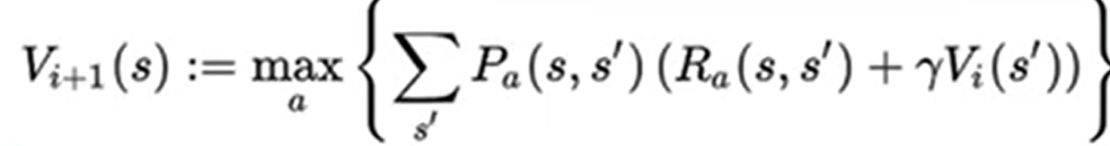

The probability function P(s, s’) is created by calculating the conditional probability function described in the videos. This includes dividing the number of instances of a next state s’ from a state s and action a and then dividing this from the total number of next states for that state action pair.

$P(s' | s, a) = \frac{Number of Transitions (s, a -> s') }{Total Number of Transitions (s, a -> any s')}$

Here in this MDP implementation the reward function was set to be the following:

R(s, s’) =
- -0.01 if a = Pick
- +1 if valid place
- -1 if invalid place
- +6 if final state s = (5, null)

Here I first set any pick action to have a negative cost. Since I have both pick and place actions, if pick had reward = 0, then the MDP agent could pick forever with no cost. There would be no incentive to finish quickly. Conversely, I want this penalty to be smaller than the other rewards so that it doesn't just avoid picking altogether. Furthermore, the reward is set to +1 if the matching color is placed after being picked. A reward of -1 is given to any color dice which is placed without being picked before. This incentivizes the correct pick-place pair actions sequence seen in my results. Finally, I want the reward for reaching the final state of placing all 5 dice to be the key objective. Without it, it might be indifferent between finishing and hovering near completion. Thus, I made this have the highest reward.

Figure 5 shows the results of the MDP. In this figure, we can double check the accuracy of the model based on the results of the Demos 2, 4, 6. We can see that in demo 2 and 6 green is chosen first while for demo 4 red is chosen first. This is correctly shown in state = ( k = 0, h = None), where the green action trace has a probability of 2/3 = 0.6667 while the red action trace correctly has 1 - 2/3 = 0.3333. We can say that since these are both "picking" actions that the reward is the correct -0.01 I set it too.

Subsequently we can see that the corresponding place action has a probability of 100%. This is expected and correct. The input demo action list given to calculate the probabilities does not contain any mismatched pick-place pairs. Thus in the graph all the place actions have 100% probability as there is only 1 color dice to place: the same one that got picked up.

Finally, we can see that for the final state = ( k = 5, h = None) we have two places from green and blue. This is once again correct as for the demos 2 and 4 green is the last pick-place pair and blue is the last pair for demo 6. Once again for the pick part of this action ( k = 4, h = None), the probability of choosing either green or blue is correctly 2/3 and 1 - 2/3.

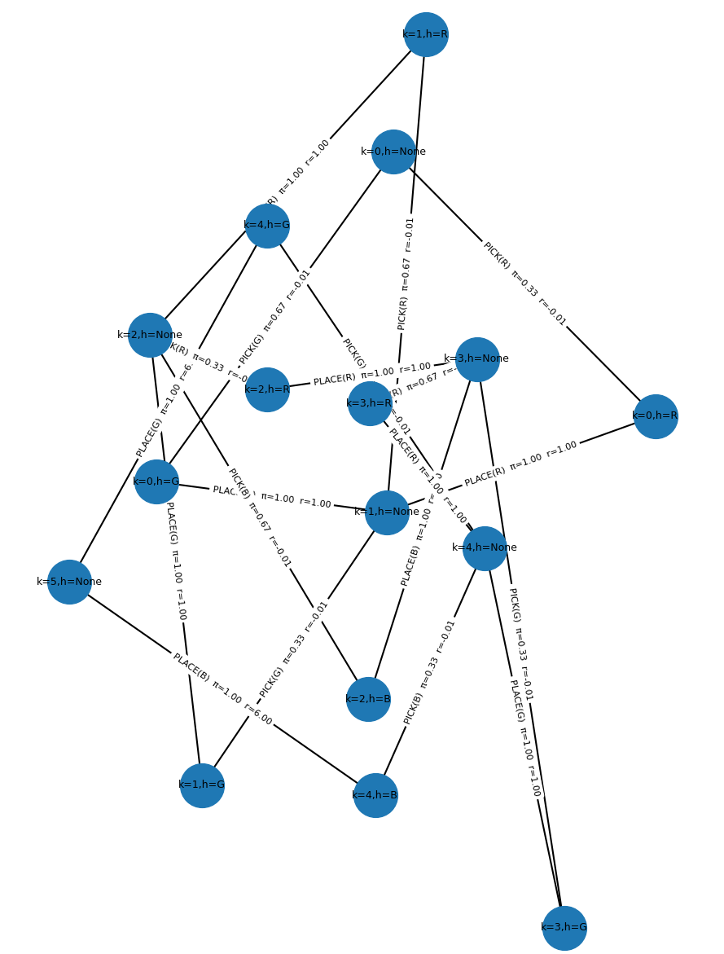
Figure 5: MDP Graph for Demos 2, 4, and 6

